SHORNCLIFFE DRIVE
JUNIOR SPORTS PITCH PARK

KEY PROPOSAL
- Junior sports park for under 14-year-olds
- Cycle and pedestrian friendly
- Multi surface floodlit mini sports pitches
- Support social amenities
- Wooded recreation area and landscaped garden area
- Grass sports pitches

Phased project
- Multi floodlit sports pitch arena
- Cycle and pedestrian footpaths within park area
- Sports and social pavilion
- Perimeter fencing and access points
- Vehicle drop off and access points
- Grass pitches
- Cycle features
- Design, Management and Maintenance
- Governance
- Funding
Mini Tennis Court Guidance
Mini tennis has been developed for children aged 4 – 12+ years through 3 graduating stages of tennis that are suitable for their age and ability. Each stage is identified by a colour:
RED emphasises fundamental sporting skills such as movement and coordination and learning to play the game.
ORANGE introduces a bigger court and low bounce tennis balls to give players time to play good tennis shots.
Size of court
There is no fixed size, design, or orientation – the design can be based on the available space, number of children likely to use the facility, the area should be bright and vibrant so that children are attracted to the multi-sport club environment, and additional features could be added to include a practise wall or line markings like targets to create a fun environment. Whilst the size of courts is not set in stone, however minimum run backs and side runs have been established which take into consideration safety and playability. Ideally if there is more than one court, they would be better side by side. If space allows, red sized courts should be separate from orange sized courts.
Low fencing would be preferable on the sides of the court to allow easy viewing and easy access through a small, attached gate. Higher raised fencing would be suitable at each end of the court in order to stop the ball leaving the court area.
Dimensions
Red court
Length 11m plus run back 3m at each end = 17m
Width 5.5m plus 1.5m at each side = 8.5m
Orange court
Length 18m plus run back 3m at each end = 24m
Width 8.5m plus 2.5m at each side = 13.5m

Floodlighting
If possible, floodlighting should be provided so that court activity times can be extended minimum illumination standards should be applied.

Court surface
Wet pour safety surfacing
- Key Features:
-Impact absorbing
- -Environmentally friendly
- -Continuous seamless surface
- -Porous/fast draining
- -Year-round use
- -Ideal for patterns/graphics
- -Highly UV stable, reducing colour loss
- -Wheelchair friendly
- -Durable
- -Maintenance free
- -Tested to BS EN 1177:2018
- -Smooth, even finish

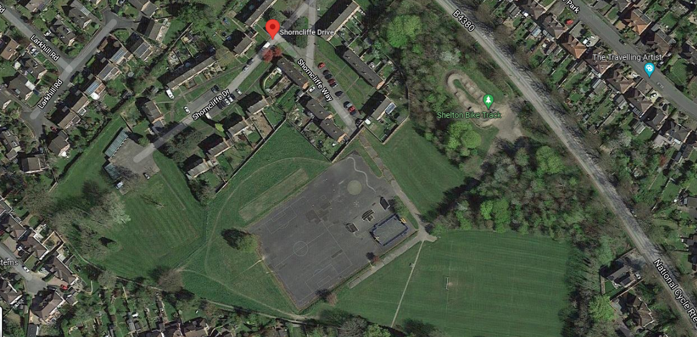

David Kilby
SPFA Secretary 2021-2025 Proposal

